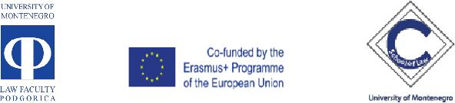____________________________________________________________________
Monitoring visit to the Erasmus+ CBHE project 573866-EPP-1-2016-1-ME- EPPKA2-CBHE-JP

Capacity Building of the Faculty of Law, University of Montenegro-curricula refreshment, boosting of international cooperation and improving human, technical and library”

Venue | University of Montenegro Faculty of Law
 | Dean's Office
 | 13 July 2
 | Podgorica
List of | Darko Drašković, Sudski savjet  Sutkinja, Senka Danilović, Centar za obuku u sudstvu i državnom tužilaštvu  Prof. dr Biljana Djuričin, LF  Prof. dr Ljiljana Jokić, LF  Prof. dr Gordana Paović Jeknić, LF  Doc.dr Bojana Lakicevic Djuranović, LF  Prof. dr Vladimir Savković, , LF  Prof. dr Nevenka Bogojević Gluščević, LF  Prof. dr Aneta Spaić, LF  Dr Nikola Dožić, LF  Vanja Drljević, NEO  Ranko Lazović, NEO
participants
Working day | Wednesday, 3 October 2018, 9.30
\ |  | PROGRAMME
Wednesday, November 8, 2017
9:30-10:30 |  |  | - Reporting on the Status quo of CABUFAL
 |  |  | - -Ongoing activities and work packages
 |  |  | (study visits, trainings, procurements);
 |  |  | - Financial issues;
- Management issues: MB & QAB.

- Documents to be presented:
Copy of the Partnership agreement(s) signed within the partnership ♣ Organigram of the project organisation with the identification of the responsible bodies/persons for what concerns the project management and the implementation of the different work packages; ♣ Minutes of the last coordination meeting ♣ Copy of the most relevant pages of the project website and any other dissemination material/results (e.g. leaflet, poster, brochure, media coverage, etc.) ♣ Copy of the Quality Assurance / Evaluation reports produced so far (if any) ♣ Copies of the products/output produced so far

 |  | 10Č | - Follow up on the Technical Report
10:30-11:00 |  |  | Opening and discussion on contentious issues
 |  |  | by the coordinating institution
10:30-11:00 |  |  | Opening and discussion on contentious issues
 |  |  | by the NEO

